Circuit Analysis (Lab10)

Experiment 9: Verification of Thevenin’s Theorem

Name: M.Fahad Registration No: 2025-CE-105
Objective
The objective of this lab is verify Thevenin’s theorem and to find the full load current.

Apparatus Required
Sr. no | Apparatus | Range | Quantity
1 | Regulated Power Supply | Standard | 1
2 | Signal Generator | Standard | 1
3 | Oscilloscope | Standard | 1
4 | Digital Multimeter | Standard | 1
5 | Breadboard & Wires | Standard | As Required
6 | Resistors | 1k, 330 ohms | 1,3
7 | Potentiometer | Standard | 1

Description
Statement:
Any linear bilateral, active two terminal network can be replaced by an equivalent voltage source
(VTH). Thevenin’s voltage or V OC in series with looking pack resistance RTH.

Precautions:
- Voltage control knob of RPS should be kept at minimum position.
- Current control knob of RPS should be kept at maximum position

Procedure:
2. Placing Components:
All components were selected from the “Pick Devices” menu in Proteus. The DC source, resistors, ground, and measuring instruments were placed on the workspace.
3. Circuit Connections:
The circuit was connected as per the given diagram. The resistors were connected in the required network configuration, and the load resistance was connected across the output terminals.
4. Measurement of Current (Initial Setup):
The DC ammeter was connected in series with the load resistance. The circuit was completed, and current through the load was observed.
5. Determination of Thevenin Voltage (Vth):
To find Vth, the load resistance was removed from the circuit.
A voltmeter was connected across the open terminals, and the open circuit voltage was measured as 5V.
6. Determination of Thevenin Resistance (Rth):
To find Rth, the DC source was replaced with a short circuit.
A multimeter (ohmmeter mode) was connected across the open terminals, and the equivalent resistance was measured as 495Ω.
7. Equivalent Circuit Construction:
A new circuit was constructed using the obtained values:
- Thevenin Voltage = 5V
- Thevenin Resistance = 495Ω
The load resistance was connected in series with Rth and the DC source.
8. Running the Simulation:
After completing all connections, the simulation was started using the Run button in Proteus.
9. Observation and Verification:
The current through the load in the equivalent circuit was measured and compared with the original circuit.
It was verified that both currents are equal, thus confirming Thevenin’s Theorem.

Circuit - 1: To find load current
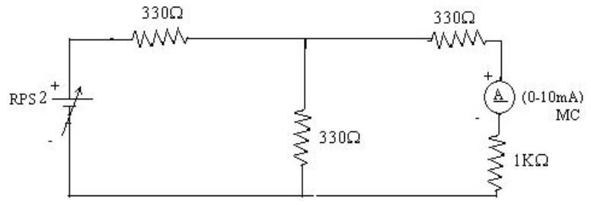

To find VTH
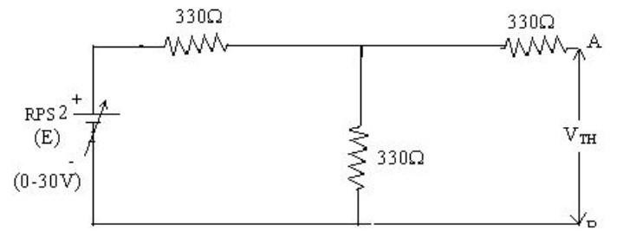

To find RTH
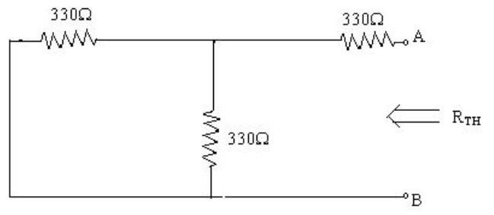

Thevenin’s Equivalent circuit:
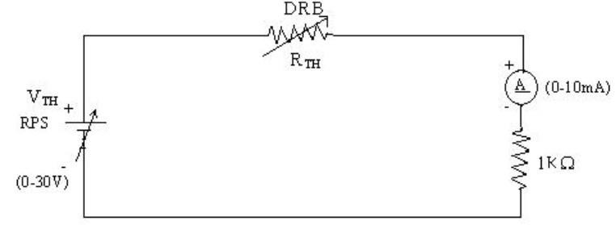

Thevenin Practical Values

 | E(V) | VTH(V) | RTH(ohms) | I_{L} (mA)
 |  |  |  | Circuit - I | Equivalent Circuit
Values | 10V | 5V | 495Ω | 3.34mA | 6.69mA

Post Lab Questions
  - What is Thevenin’s Theorem?
2Thevenin’s Theorem is a fundamental theorem used in electrical engineering to simplify complex circuits.
It states that any linear bilateral circuit containing voltage sources and resistances can be replaced by an equivalent circuit.
The equivalent circuit consists of a single voltage source called Thevenin voltage ((V_{th})) and a single resistance called Thevenin resistance ((R_{th})).
This simplified circuit behaves exactly like the original circuit from the load’s point of view.
To find (V_{th}), the load resistor is removed and the open-circuit voltage is calculated.
To find (R_{th}), all independent voltage sources are short-circuited and current sources are opened.
Thevenin’s Theorem makes circuit analysis easier and reduces complicated calculations.
It is widely used in analyzing power systems, electronic circuits, and network troubleshooting.

  - What are the applications of Thevenin’s Theorem?
Applications of Thevenin’s Theorem are given below:
- It is used to simplify complex electrical circuits into a simple voltage source and resistance.
- It helps in analyzing load current and load voltage easily.
- It is widely used in troubleshooting and testing electrical networks.
- Engineers use it in the design of electronic and communication circuits.
- It is useful for calculating maximum power transfer to the load.
- It helps in studying the effect of changing load resistance in a circuit.
- It is applied in power system and control system analysis.
- It saves time and reduces mathematical calculations in circuit analysis.

  - What are the theoretical and practical limitations of Thevenin’s Theorem?
Theoretical and practical limitations of Thevenin’s Theorem are:
- The theorem is applicable only to linear and bilateral circuits.
- It cannot be directly used for non-linear components like diodes and transistors.
- It is not suitable for circuits containing only dependent sources without special treatment.
- The theorem works mainly for steady-state electrical networks.
- Calculating Thevenin resistance in large circuits can become difficult and time-consuming.
- Errors may occur in practical circuits due to internal resistance and measurement inaccuracies.
- It is less effective for analyzing circuits with rapidly changing loads.
- Practical components may not behave ideally, which can affect the accuracy of results.

